May 9, 2025

NOTIFICATION OF TEMPORARY CONSTRUCTION ACCESS CHANGE – FOR CHIEFTAN AND RIBCOR HOLDINGS INC.

# TOWNSHIP OF SCUGOG

Dear Resident,

Ribcor Holdings Inc. and Chieftan have received approval from the Township of Scugog to develop plans of subdivision west of Union Avenue, on the south side of Forestlane Way and north side of Josephine Street.

A new temporary construction access route has been approved by the Township due to the Union Avenue reconstruction project by the Township. Union Avenue will be temporarily closed between Josephine Street and King Street. All construction traffic for these two subdivisions will temporarily be from via Simcoe Street - Major Street -Union Avenue -Forestlane Way until reconstruction of Union Avenue is completed.

# The temporary road closure on Union Avenue will be in place from late May 2025 – November 2025. This schedule could vary as the work will be weather dependent.

Please refer to the map on the back of this notice for the Temporary Construction Access details.

# Should you have any questions regarding this matter please feel free to contact:

Vince Barrese Engineering Technologist Township of Scugog [vbarrese@scugog.ca](mailto:vbarrese@scugog.ca) (905) 985-7346 ext. 175

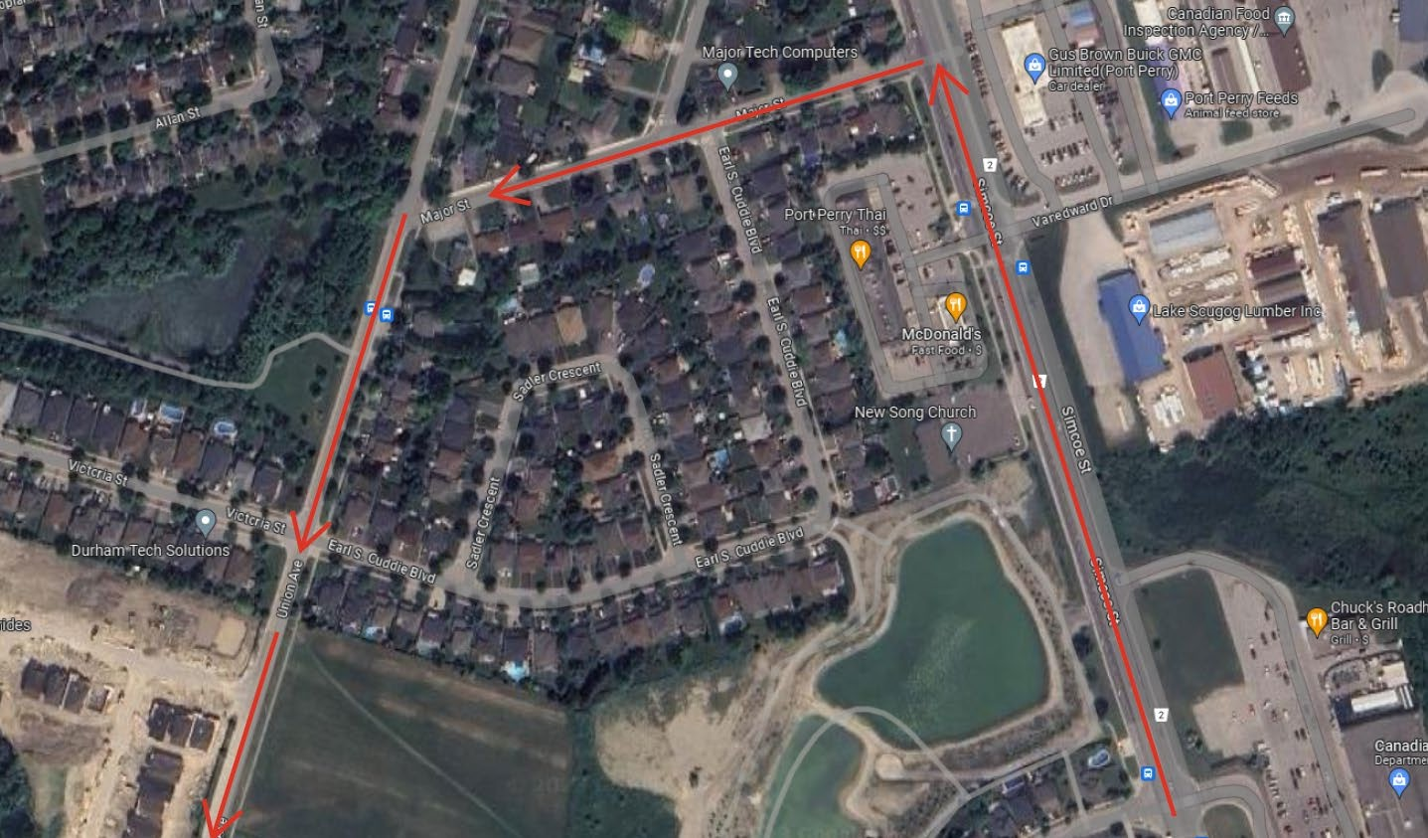

Figure 1: Temporary Construction Access from Simcoe Street to Major Street, to Union Avenue, to Forestlane Way

Page 2